Makwana N.¹, Garret G.S.², Duncan M.J.³, Morris R.E.³, Lennon A¹, Menary G.¹
¹School of Mechanical and Aerospace Engineering, Queen’s University, Belfast, UK
² Polymer Processing Research Centre, Queen’s University, Belfast, UK
³School of Chemistry, University of St Andrews, Scotland, UK
email: (n.makwana@qub.ac.uk)

Simulating Nitric Oxide diffusion within MOF-based Polymers Used to Prevent Catheter Related Thrombosis and Infection
Makwana N.¹, Duncan M.J.², Morris R.E.², Lennon A¹, Menary G.¹
¹School of Mechanical and Aerospace Engineering, Queen’s University, Belfast, UK
²School of Chemistry, University of St Andrews, Scotland, UK
email: (n.makwana@qub.ac.uk)

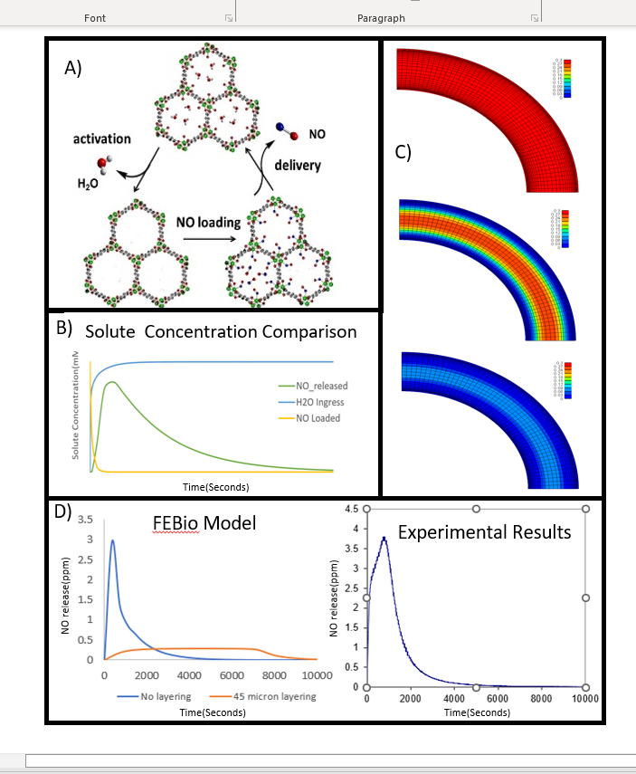
Introduction
Infection and thrombosis are two major complications that can occur when a patient is catheterised. Nitric Oxide (NO) is an effective surgical adjuvant to mitigate such complications [1]. Incorporating the ability to release NO from catheters could therefore help overcome issues related to catheterization.
Figure 1 (A) Cycle of loading and releasing NO from MOFs. ​(B) Solute concentration change with time. (C) Simulation of NO activation & release through polymer. (D) NO release profiles comparison, model (LHS) and experimental (RHS).
Recently, MOFs (Metal Organic Frameworks) have been suggested as a potential delivery substrate. Their high porosity and surface area are ideal for application in gas handling, storage, and drug delivery [2]. Delivery of NO is via an exchange mechanism with water from the NO loaded MOF particles (Fig1A). In medical practice, when the catheter is inserted, moisture (H₂O) will diffuse in, be preferentially bound to the MOF, releasing NO for outward diffusion to the catheter surface and released into the blood stream. Achieving appropriate MOF formulation and catheter dimensions to enable precise control of release can be time consuming to determine experimentally, so a model of water-initiated NO release and diffusion could help design clinically relevant devices. This study aims to simulate NO release from catheters via a multi-phase reaction-diffusion simulation using the finite element (FE) method.

Materials and methods
MOF containing tubing of similar dimensions to catheters used in cardiovascular procedures (1.75 mm OD with 1.25mm ID) using medically relevant polymers were manufactured at the Polymer Processing Research Centre. The NO release profile from these tubes were measured using chemiluminescence under physiological conditions (Fig1 D RHS). Determination of the diffusion coefficients for NO and H₂O are still underway for these polymer-MOF tubes; initial studies have therefore focussed on the influence of diffusion properties on potential release profiles.
A multi-solute transport FE model was built with FEBio 2.4.0 software suite to allow water ingress within the polymer-MOF matrix, which releases NO upon contact with the polymer-MOF matrix. The FE model has a quarter tube geometry with a Hex8 mesh biased radially towards the tube periphery, three solutes representing bound and diffusing NO and H₂O within the geometry defined with polymer material property. A parametric study ranging with different solute concentrations, solute boundaries and for a time range of 6 hours were processed to understand the change in flux and concentration profiles with respect to time.

results and Discussion
This work demonstrates the ability of FE model to study NO gas release from complex MOF based polymeric catheters. Simulations predicts NO release profiles in terms of solute flux (Fig 1C). Solutes (within material) exhibits temporal variations in concentration shown in (Fig 1B), representing the activation of NO gas from its solid bound state diffusing outwards from within the material. One of the promising approaches on extending long term NO release and reduce initial bursts of NO is by adding a layer of coating with neat polymer, currently simulated via the FE model as shown in (Fig 1D LHS). This result provides the confidence in FE method for simulating NO release in catheters.
Initial concentration based parametric study showcases that relative diffusion coefficient of NO and H₂O, outer coating thickness, and reaction rate correlate in a steady release of NO through the surface and keeps the NO levels in check. Moreover, the activating H₂O governs the rate of release of NO which further needs to be analysed and measures need to be taken to control the H₂O ingress, thereby prolonging the desired NO release properties of polymer-MOF based catheters.

References
[1] Krausz A. et al. Future Sci OA, 2015, 1(1), Fso56.
[2] McKinlay A.C. et al. Angew Chem Int Edit, 2010, 49, 6260. [3] Paradise W.A. et al. Int J Mol Sci, 2010, 11, 2715. [4] Douglass M. et al. ACS Appl Bio Mater, 2022, 5, 700.

